Make sure Close #intFileNum is fixed in update code of
adaeptdblib (done).

84: gstrAppNewVersion = mstrAppNewVersion
'
85: Close #intFileNum ' Close data file.

86: If blnTheAppLoaderUpdateStatus Then

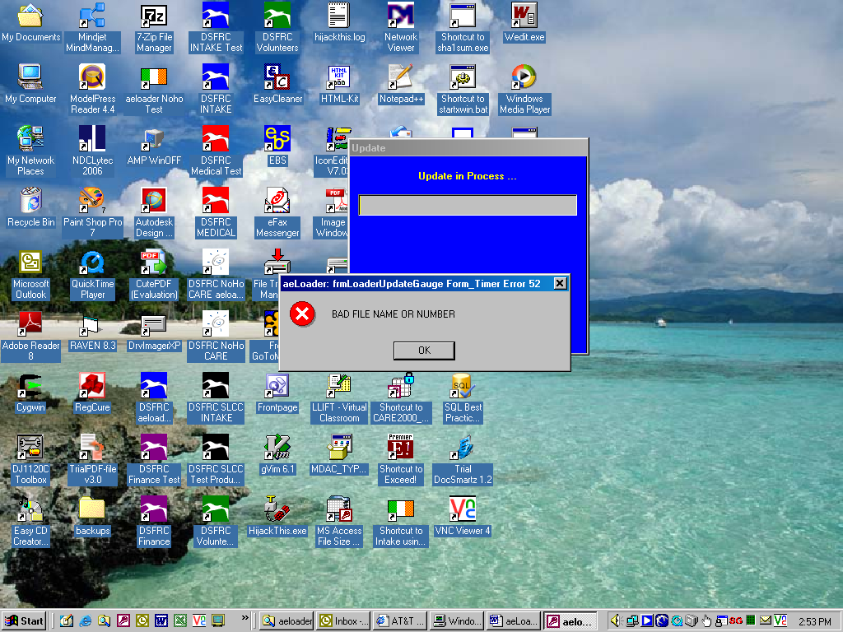

06/07/2007
